Practical: 1
Aim: To create student registration form using html and css

Program:
<!DOCTYPE html>
<html>
<head>
<title>Registration Form</title>
<style>
body {
font-family: Arial, sans-serif;
margin: 30px;
}
form {
width: 400px;
padding: 50px;
border: 2px solid #333;
border-radius: 10px;
}
label {
display: block;
margin-top: 10px;
font-weight: bold;
}
input, select, textarea {
width: 100%;
padding: 8px;
margin-top: 5px;
}
.gender, .hobbies {
width: auto;
}
button, input[type="submit"], input[type="reset"] {
width: 48%;
padding: 10px;
margin-top: 15px;
}
</style>
</head>
<body>
<h2>Student Registration Form (Tisha Amit - 119)</h2>
<form action="#" method="post">
<!-- Full Name -->

<label for="name">Full Name:</label>
<input type="text" id="name" name="name" placeholder="Enter your full name"
required><br>
<!-- Email -->
<label for="email">Email:</label>
<input type="email" id="email" name="email" placeholder="Enter your email" required><br>
<!-- Password -->
<label for="password">Password:</label>
<input type="password" id="password" name="password" minlength="6" required><br>
<!-- Phone -->
<label for="phone">Phone Number:</label>
<input type="tel" id="phone" name="phone" pattern="[0-9]{10}" placeholder="10-digit
number"><br>
<!-- Gender -->
<label>Gender:</label>
<input type="radio" class="gender" name="gender" value="Male"> Male
<input type="radio" class="gender" name="gender" value="Female"> Female
<input type="radio" class="gender" name="gender" value="Other"> Other
<!-- Date of Birth -->
<br><label for="dob">Date of Birth:</label>
<input type="date" id="dob" name="dob" required><br>
<!-- Course Selection -->
<label for="course">Select Course:</label>
<select id="course" name="course" required>
<option value="">--Select--</option>
<option value="B.Tech">B.Tech</option>
<option value="BCA">BCA</option>
<option value="BBA">BBA</option>
<option value="MBA">MBA</option>
</select><br>
<!-- Hobbies -->
<label>Hobbies:</label>
<input type="checkbox" class="hobbies" name="hobby1" value="Reading"> Reading
<input type="checkbox" class="hobbies" name="hobby2" value="Sports"> Sports
<input type="checkbox" class="hobbies" name="hobby3" value="Music"> Music<br>
<!-- Upload Photo -->
<label for="photo">Upload Photo:</label>

<input type="file" id="photo" name="photo" accept="image/*"><br>
<!-- Address -->
<label for="address">Address:</label>
<textarea id="address" name="address" rows="3" placeholder="Enter your
address"></textarea><br>
<!-- Submit & Reset -->
<input type="submit" value="Register">
<input type="reset" value="Clear">
</form>
</body>
</html>

Output:
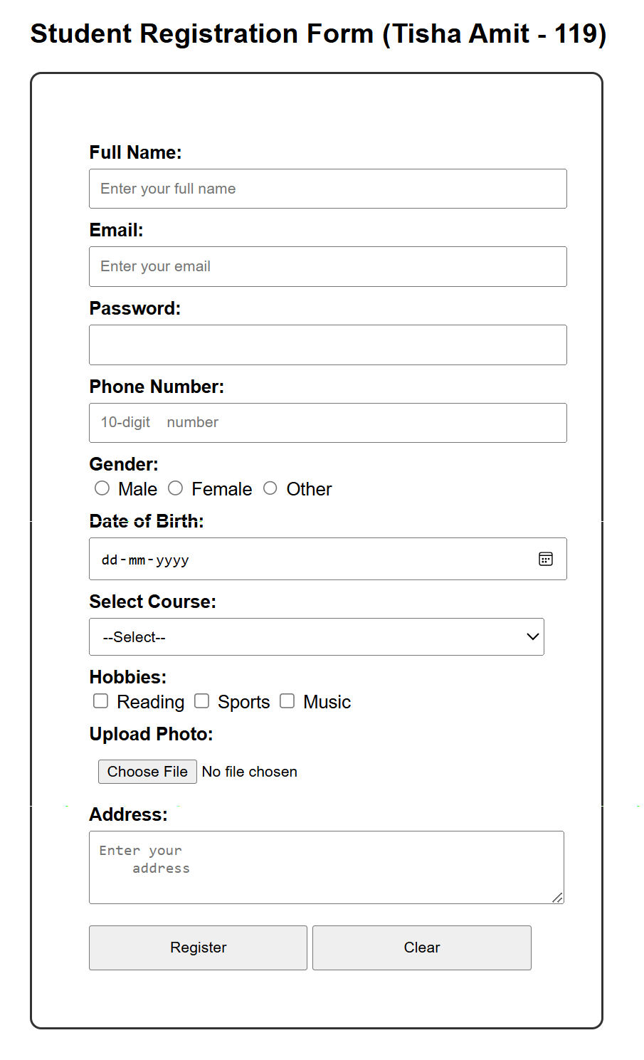

Program:
<!DOCTYPE html>
<html>
<head>
<title>Registration Form</title>
<style>
body {
font-family: Arial, sans-serif;
margin: 30px;
}
form {
width: 400px;
padding: 50px;
border: 2px solid #333;
border-radius: 10px;
}
label {
display: block;
margin-top: 10px;
font-weight: bold;
}
input, select, textarea {
width: 100%;
padding: 8px;
margin-top: 5px;
}
.gender, .languages, .subjects {
width: auto;
}
button, input[type="submit"], input[type="reset"] {
width: 48%;
padding: 10px;
margin-top: 15px;
}
</style>
</head>
<body>
<h2>Student Registration Form (Tisha Amit - 119)</h2>
<form action="#" method="post">
<!-- Full Name -->

<label for="name">Full Name:</label>
<input type="text" id="name" name="name" placeholder="Enter your full name"
required><br>
<!-- Email -->
<label for="email">Email:</label>
<input type="email" id="email" name="email" placeholder="Enter your email" required><br>
<!-- Phone -->
<label for="phone">Phone Number:</label>
<input type="tel" id="phone" name="phone" pattern="[0-9]{10}" placeholder="10-digit
number"><br>
<!-- Gender -->
<label>Gender:</label>
<input type="radio" class="gender" name="gender" value="Male"> Male
<input type="radio" class="gender" name="gender" value="Female"> Female
<input type="radio" class="gender" name="gender" value="Other"> Other
<!-- Date of Birth -->
<br><label for="dob">Date of Birth:</label>
<input type="date" id="dob" name="dob" required><br>
<!-- Date Selection -->
<label for="date">Select Date:</label>
<select id="day" name="day" required>
<option value="">--Select Day--</option>
<option value="1">1</option>
<option value="2">2</option>
<option value="3">3</option>
<option value="4">4</option>
<option value="5">5</option>
<option value="6">6</option>
<option value="7">7</option>
<option value="8">8</option>
<option value="9">9</option>
<option value="10">10</option>
<option value="11">11</option>
<option value="12">12</option>
<option value="13">13</option>
<option value="14">14</option>
<option value="15">15</option>
<option value="16">16</option>
<option value="17">17</option>
<option value="18">18</option>
<option value="19">19</option>
<option value="20">20</option>
<option value="21">21</option>
<option value="22">22</option>
<option value="23">23</option>
<option value="24">24</option>
<option value="25">25</option>
<option value="26">26</option>
<option value="27">27</option>
<option value="28">28</option>
<option value="29">29</option>
<option value="30">30</option>
<option value="31">31</option>
</select><br>
<select id="month" name="month" required>
<option value="">--Select Month--</option>
<option value="January">January</option>
<option value="February">February</option>
<option value="March">March</option>
<option value="April">April</option>
<option value="May">May</option>
<option value="June">June</option>
<option value="July">July</option>
<option value="August">August</option>
<option value="September">September</option>
<option value="October">October</option>
<option value="November">November</option>
<option value="December">December</option>
</select><br>
<select id="year" name="year" required>
<option value="">--Select Year--</option>
<option value="2000">2000</option>
<option value="2001">2001</option>
<option value="2002">2002</option>
<option value="2003">2003</option>
<option value="2004">2004</option>
<option value="2005">2005</option>
<option value="2006">2006</option>
<option value="2007">2007</option>
<option value="2008">2008</option>
<option value="2009">2009</option>
</select><br>
<!-- Languages Known -->
<label>Languages Known:</label>
<input type="checkbox" class="languages" name="lang1" value="English"> English
<input type="checkbox" class="languages" name="lang2" value="Hindi"> Hindi<br>
<!-- Address -->
<label for="address">Address:</label>
<textarea id="address" name="address" rows="3" placeholder="Enter your
address"></textarea><br>
<!-- Subject -->
<label>Subject:</label>
<input type="radio" class="subjects" name="subject" value="Maths"> Maths
<input type="radio" class="subjects" name="subject" value="Science"> Science
<input type="radio" class="subjects" name="subject" value="English"> English
<!-- Submit & Reset -->
<input type="submit" value="Register">
<input type="reset" value="Clear">
</form>
</body>
</html>

Output:
